Android Studio Installation:-

# Computer requirments:

* + - * + Processor : Ryson3
        + RAM : 8GB
        + Harddisk : 1TB

1. Istallation Proccss :
2. Download

* Open browse and type download android studio open first link that is <https://developer.android.com/> follow this link to downlad.

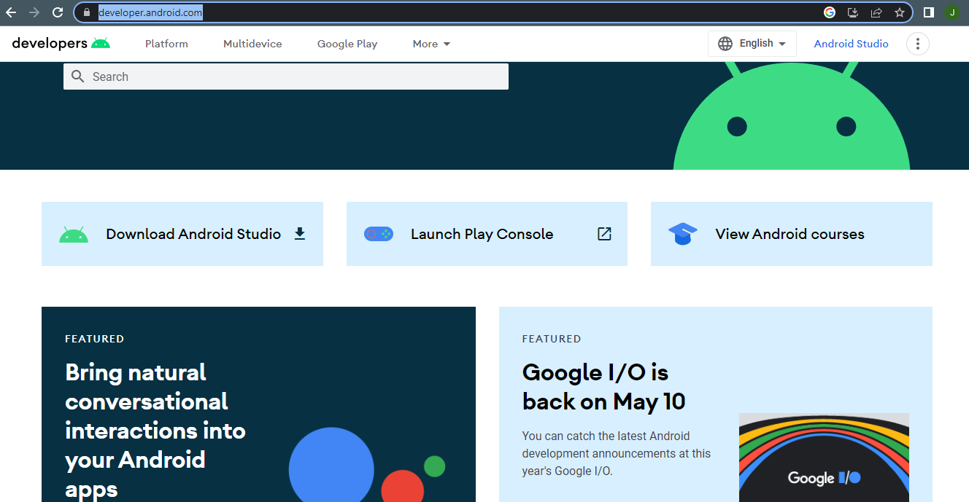

* After that click on download Android studio button

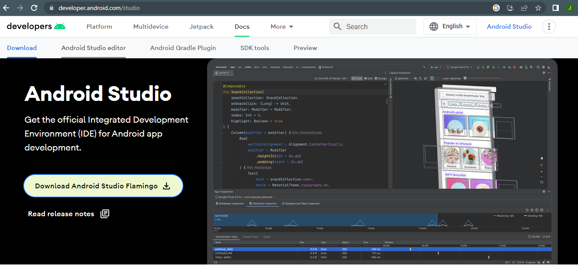

* Click on Download Android Studio Filmigo

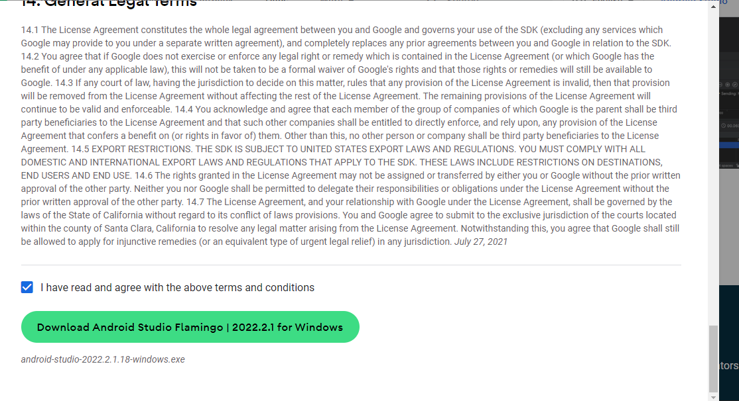

* Then read the terms and condition and then accept it and after that click on download button it will start to download the android studio for windows
* If you are in another platform then choose the options mannualy at home page.

1. Installation :

* Once your download is complete then open the file in folder

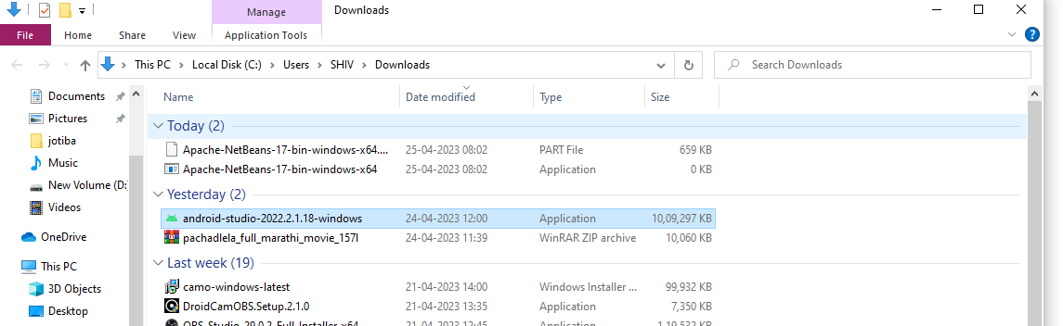

* Double click on Downloaded file then press yes this will show the the below window.

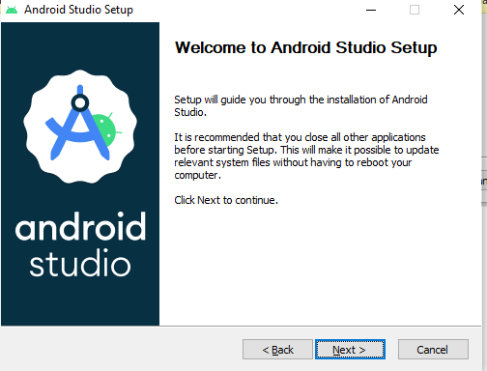

* After that just click next

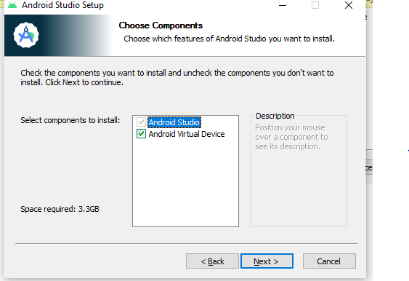

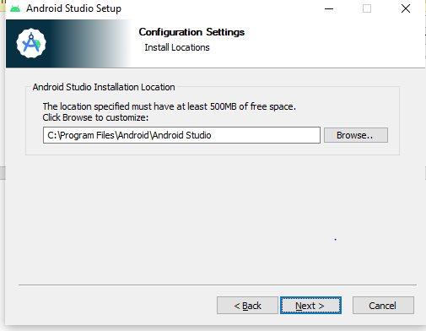

* In the above Window we give the place where the android studio will be install set as defauldt.

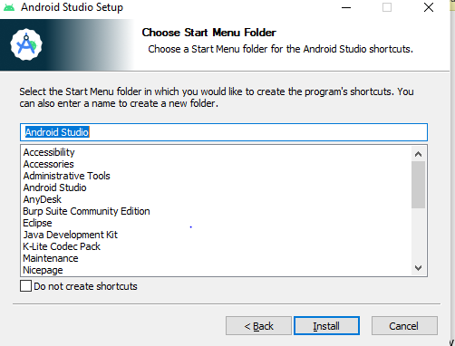

* After that just click on Install.

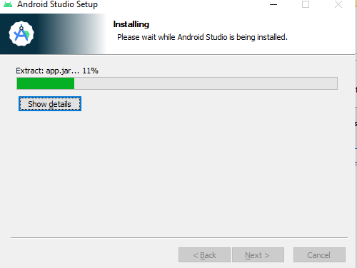

* The Installation process will start

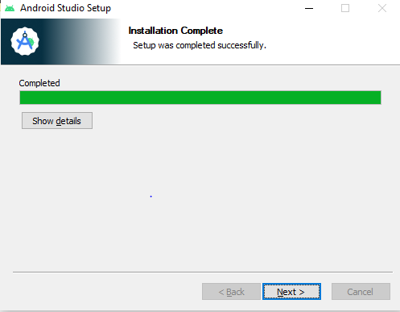

* After completing of this process click on next button

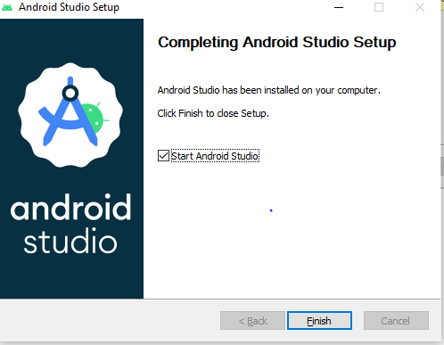

* Then click on finish button
* Note: This set up I have already installed in my computer so that it could not download the file at set up time.

1. Set-up :

* Open the app on your computer screen it will show below screen

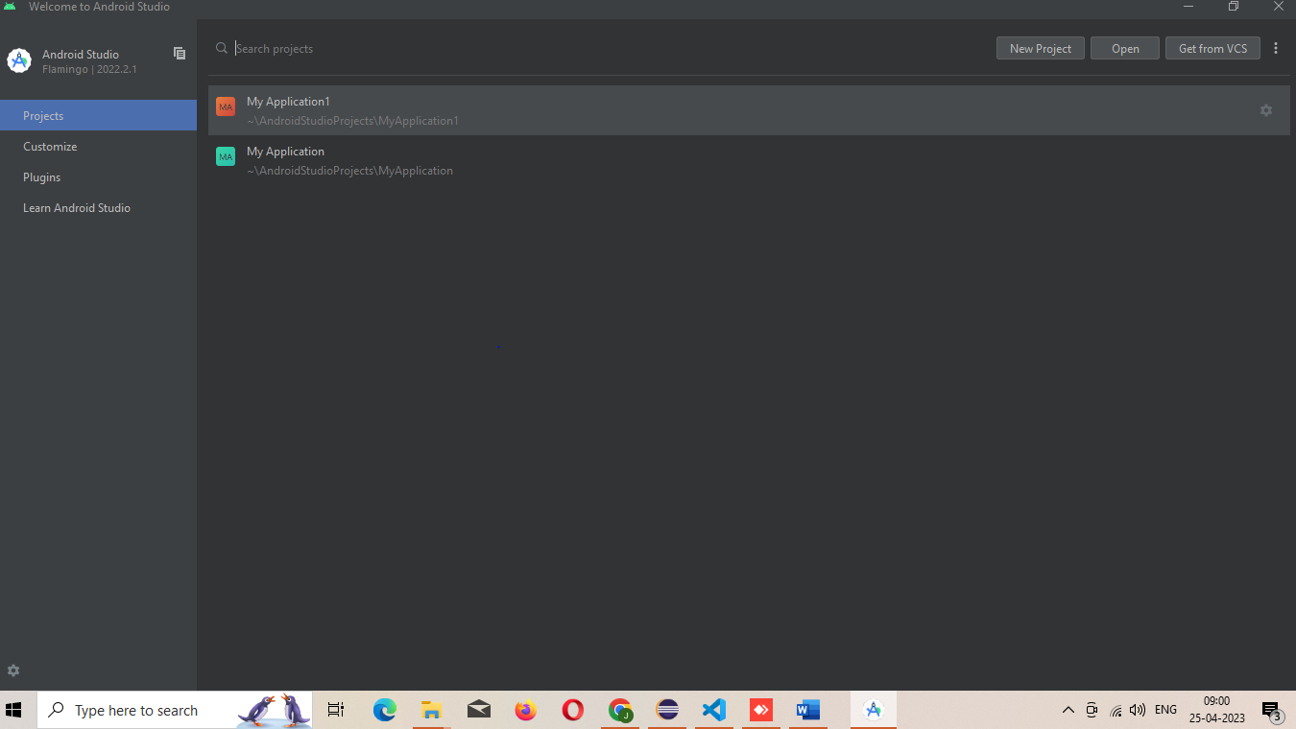

* In above just click on new project

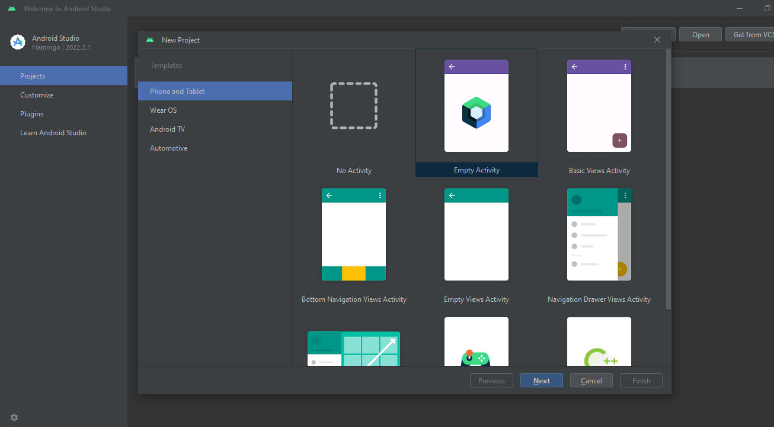

* After that choose the activity depends upon your project and click on the next button.

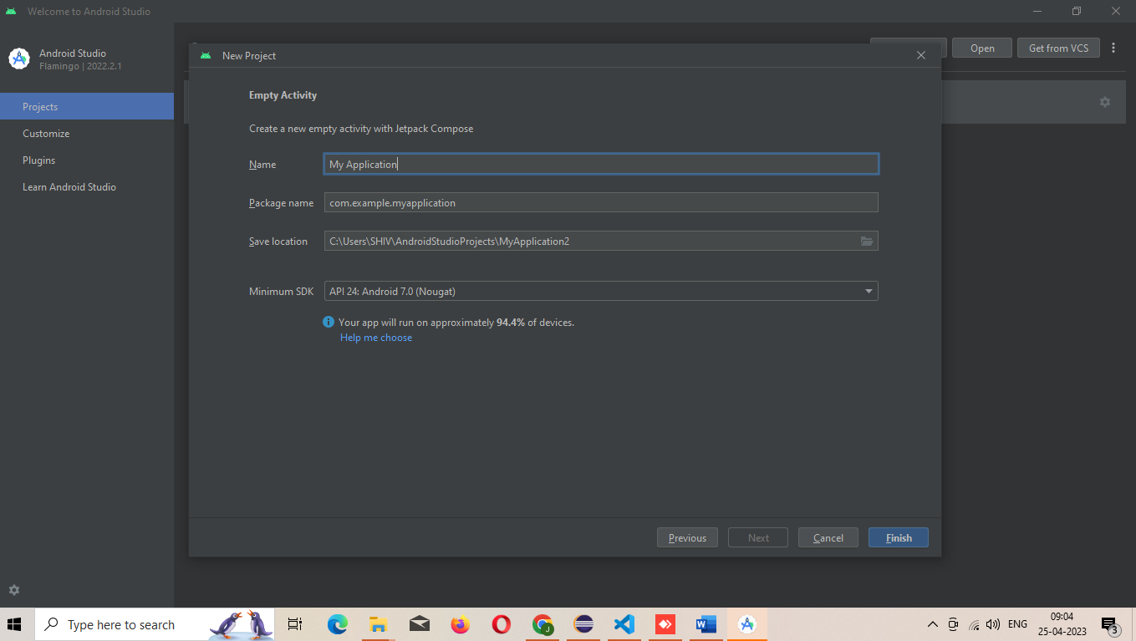

* After that you have to give the name for your application the path where you want to store the created files and select Maximum SDK option its simply take how much mobile devis you want to target. After that just click on finish.

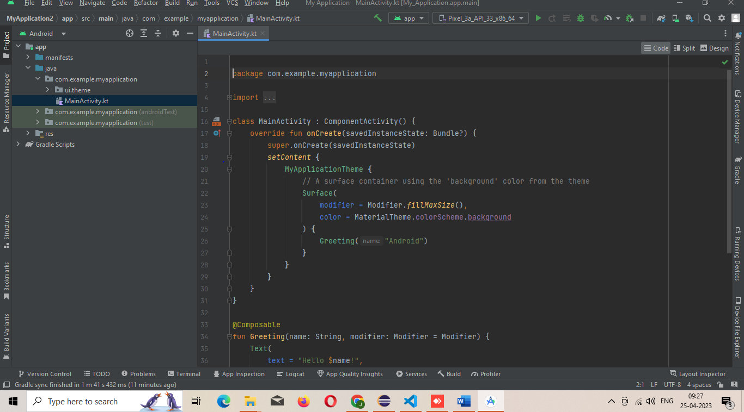

* This is the main window of every android project in the main file we have to code.
* At the right side there is a design option is available through that we can design our app also design the through the coding.

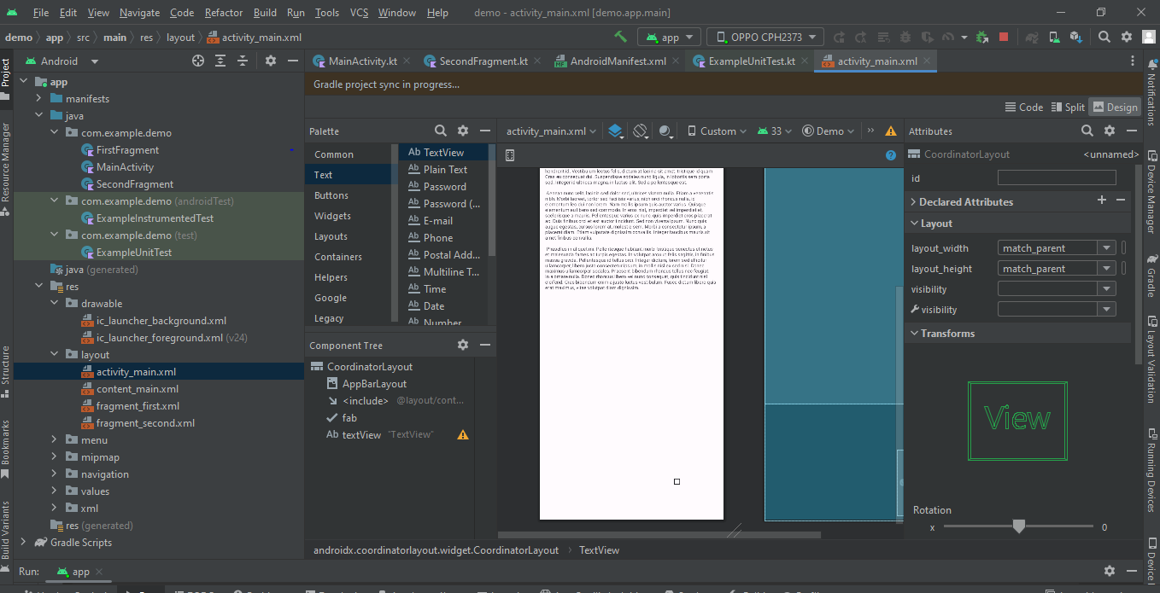

* Shown in above picture that how we can design the app simply pick and paste

1. OUTPUT : -Once you done with coding there one run symbol before press that you have to select the device there is two option you can use emulator which give mobile screen in computer or you can connect with your mobile device through usb and wifi.

Once device is connected then you can run your application on device

